**Contributor name:** EKTA DUBEY

**Book Proposed:** SCHAUM’S OUTLINE SERIES THEORY AND PROBLEMS OF STATISTICS

2/ed in SI Unites

**Total Chapters:** 19

**Total Examples:** 618

**Codable Examples:** 517

**Chapter 1: Variables and Graphs**

Example 1.1 –Non- Codable (Reason: Theoretical example with the purpose of proving a concept)

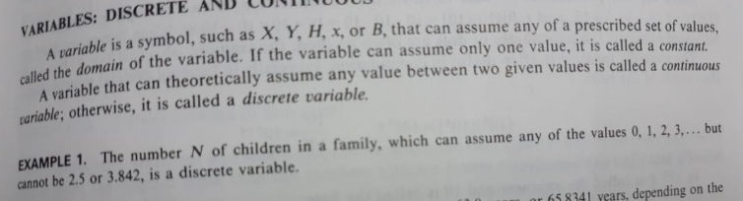

Example 1.2 –Non- Codable (Reason: Theoretical example with the purpose of proving a concept)

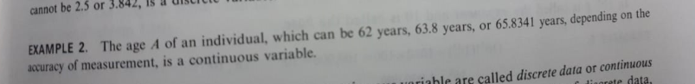

Example 1.3 – Codable

Example 1.4 – Codable

Example 1.5 – Codable

Example 1.6 – Codable

Example 1.7 – Codable

Example 1.8 – Codable

Example 1.9 – Codable

Example 1.10 – Codable

Example 1.11 – Codable

Example 1.12 – Codable

Example 1.13 – Codable

Example 1.14 – Codable

Example 1.15 – Codable

Example 1.16 – Codable

Example 1.17 – Codable

Example 1.18 – Codable

Example 1.19 – Codable

Example 1.20 –Non- Codable (Reason: Theoretical example with the purpose of proving a concept)



Example 1.21 –Non- Codable (Reason: Theoretical example with the purpose of proving a concept)



Example 1.22 – Codable

Example 1.23 – Non-Codable (Reason: Theoretical example with the purpose of proving a concept)



Example 1.24 – Non-Codable (Reason: Theoretical example with the purpose of proving a concept)



Example 1.25 – Non-Codable (Reason: Theoretical example with the purpose of proving a concept)



Example 1.26 – Non-Codable (Reason: Theoretical example with the purpose of proving a concept)



Example 1.27 – Non-Codable (Reason: Theoretical example with the purpose of proving a concept)

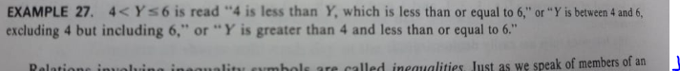

Example 1.28 – Non-Codable (Reason: Theoretical example with the purpose of proving a concept)

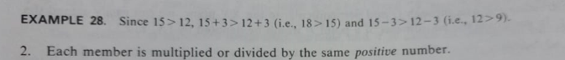

Example 1.29 – Non-Codable (Reason: Theoretical example with the purpose of proving a concept)

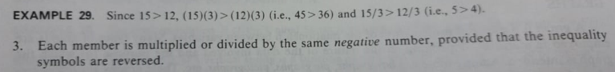

Example 1.30 – Non-Codable (Reason: Theoretical example with the purpose of proving a concept)



Example 1.31 – Codable

Example 1.32 – Codable

Example 1.33 – Codable

Example 1.34 – Codable

Example 1.35 – Codable

Example 1.36 – Codable

Example1. 1.1 – Non-Codable (Reason: Theoretical example )

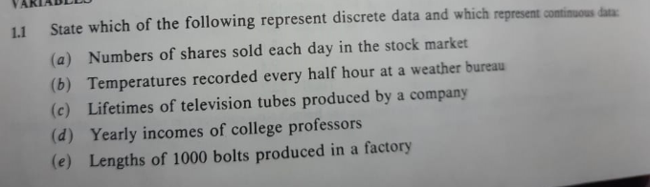

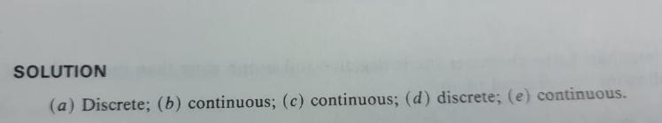

Example 1.1.2 – Non-Codable (Reason: Theoretical example )

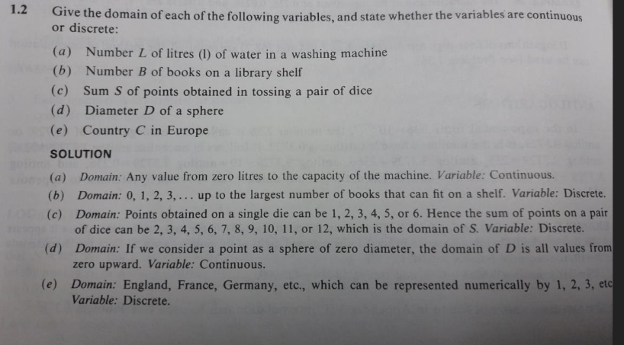

Example 1.1.3 – Codable

Example 1.1.4 – Codable

Example 1.1.5 – Codable

Example 1.1.6 – Codable

Example 1.1.7 – Codable

Example 1.1.8 – Codable

Example 1.1.9 – Codable

Example 1.1.10 – Codable

Example 1.1.11 – Codable

Example 1.1.12 – Codable

Example 1.1.13 – Codable

Example 1.1.14 – Codable

Example 1.1.15 – Codable

Example 1.1.16 – Codable

Example 1.1.17 – Codable

Example 1.1.18 – Codable

Example 1.1.19 – Codable

Example 1.1.20 – Codable

Example 1.1.21 – Codable

Example 1.1.22 – Codable

Example 1.1.23 – Codable

Example 1.1.24 – Codable

Example 1.1.25 – Codable

Example 1.1.26 – Codable

Example 1.1.27 – Codable

Example 1.1.28 – Codable

Example 1.1.29 – Codable

Example 1.1.30 – Codable

Example 1.1.31 – Non-Codable (Reason: Theoretical example with the purpose of proving a concept)

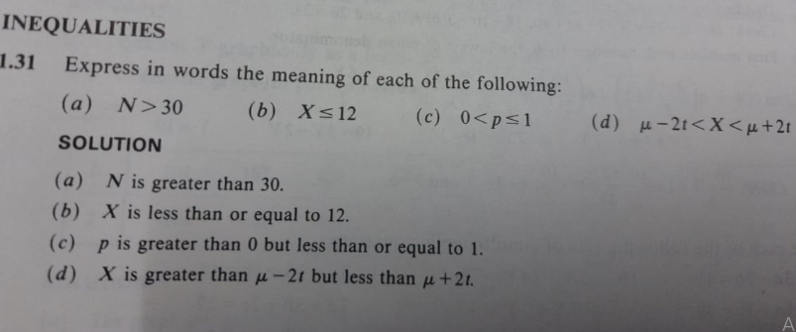

Example 1.1.32 – Non-Codable (Reason: Theoretical example with the purpose of proving a concept)

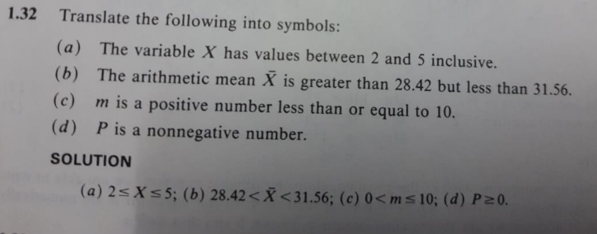

Example 1.1.33 – Codable

Example 1.1.34 – Codable

Example 1.1.35 – Codable

Example 1.1.36 – Codable

Example 1.1.37 – Codable

Example 1.1.38 – Codable

Example 1.1.39 – Codable

Example 1.1.40 – Codable

Example 1.1.41 – Codable

Example 1.1.42 – Codable

Example 1.1.43 – Codable

Example 1.1.44 – Codable

Example 1.1.45 – Codable

**Chapter 2: Frequency Distributions**

Example 2.2.1 – Codable

Example 2.2.2 – Codable

Example 2.2.3 – Codable

Example 2.2.4 – Codable

Example 2.2.5 – Codable

Example 2.2.6 – Codable

Example 2.2.7 – Non-Codable (Reason: Theoretical example with the purpose of proving a concept)

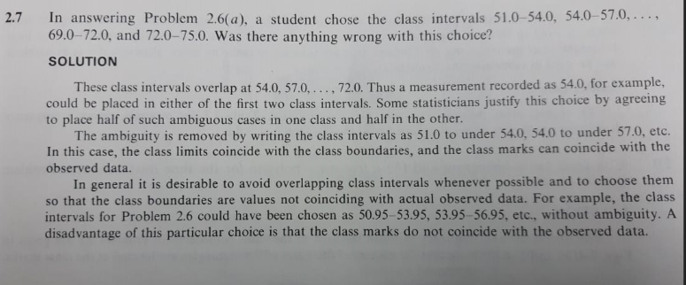

Example 2.2.8 – Codable

Example 2.2.9 – Codable

Example 2.2.10 – Codable

Example 2.2.11 –Non- Codable(Reason: Theoretical example with the purpose of proving a concept)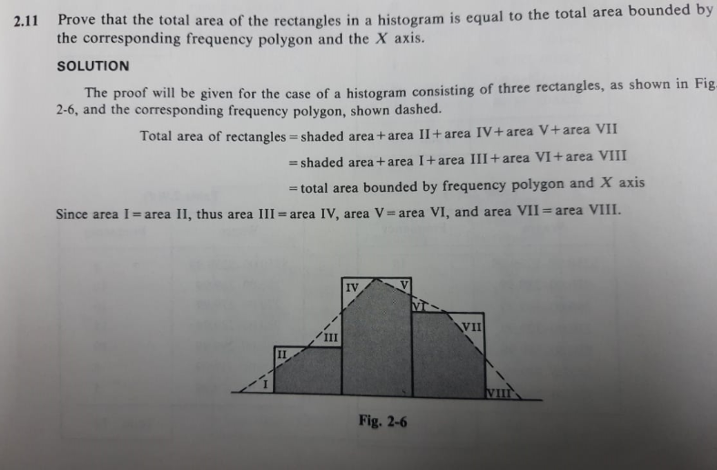

Example 2.2.12 – Codable

Example 2.2.13 – Codable

Example 2.2.14 – Codable

Example 2.2.15 – Codable

Example 2.2.16 – Codable

Example 2.2.17 – Codable

Example 2.2.18 – Codable

**Chapter 3: Measures of Central Tendency**

Example 3.1 – Non-Codable (Reason: Theoretical example with the purpose of proving a concept)

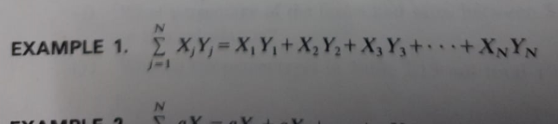

Example 3.2 – Non-Codable (Reason: Theoretical example with the purpose of proving a concept)

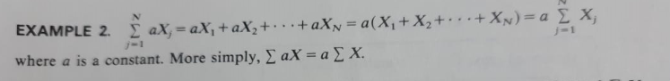

Example 3.3 – Non-Codable (Reason: Theoretical example with the purpose of proving a concept)



Example 3.4 – Codable

Example 3.5 – Codable

Example 3.6 – Codable

Example 3.7 – Codable

Example 3.8 – Codable

Example 3.9 – Codable

Example 3.10 – Codable

Example 3.11 – Codable

Example 3.12 – Codable

Example 3.13 – Codable

Example 3.14 – Codable

Example 3.15 – Codable

Example 3.16 – Codable

Example3. 3.1 –Non- Codable (Reason: Theoretical example with the purpose of proving a concept)

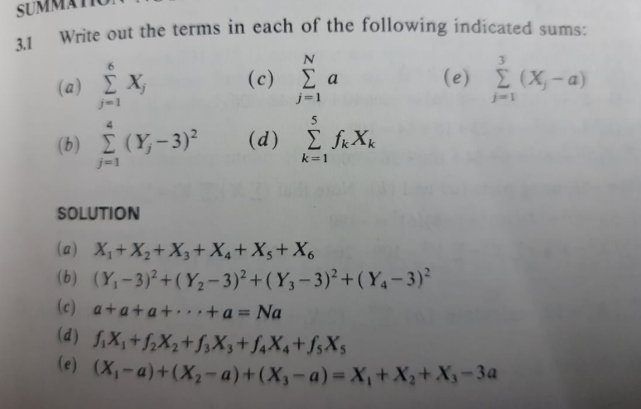

Example3. 3.2 – Non-Codable (Reason: Theoretical example with variable expression as final solution)

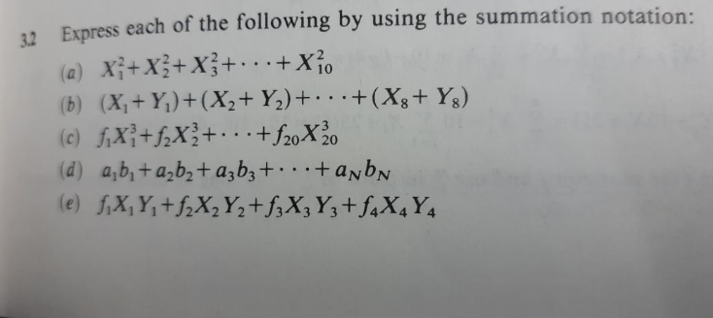

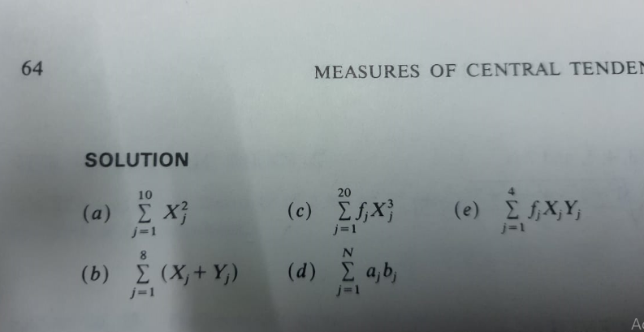

Example 3.3.3 – Non-Codable (Reason: Theoretical example with variable expression as final solution)

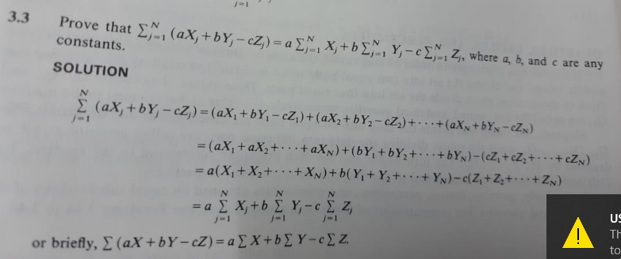

Example 3.3.4 – Codable

Example 3.3.5 – Codable

Example 3.3.6 – Codable

Example 3.3.7 – Codable

Example 3.3.8 – Codable

Example 3.3.9 – Codable

Example 3.3.10 – Codable

Example 3.3.11 – Codable

Example 3.3.12 – Codable

Example 3.3.13 – Codable

Example 3.3.14 – Codable

Example 3.3.15 – Codable

Example3. 3.16 – Non-Codable (Reason: Theoretical example with the purpose of proving a concept)

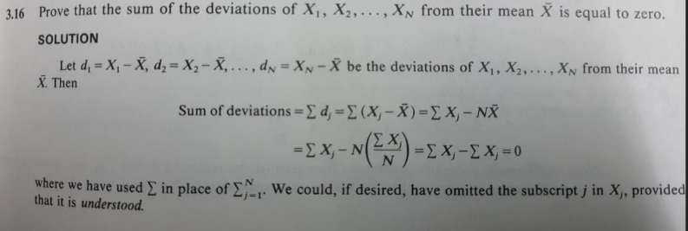

Example 3.3.17 – Non-Codable (Reason: Theoretical example with the purpose of proving a concept)

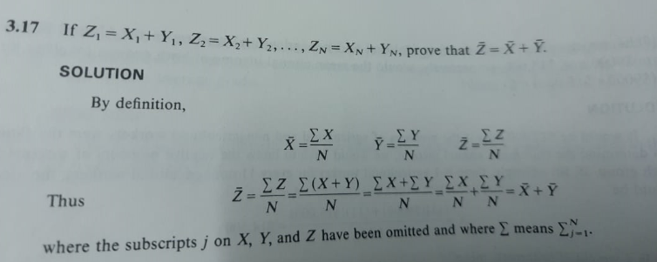

Example 3.3.18 – Non-Codable (Reason: Proving a concept and the final variable expression as final solution.)

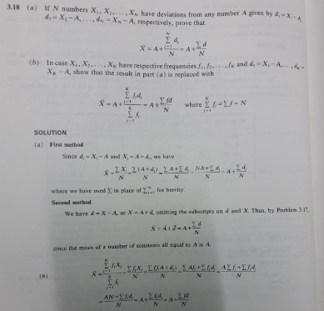

Example 3.3.19 – Codable

Example 3.3.20 – Codable

Example 3.3.21 –Non- Codable (Reason: Theoretical example with the purpose of proving a concept and variable expression as final answer)

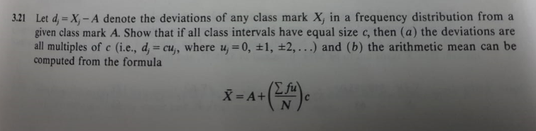

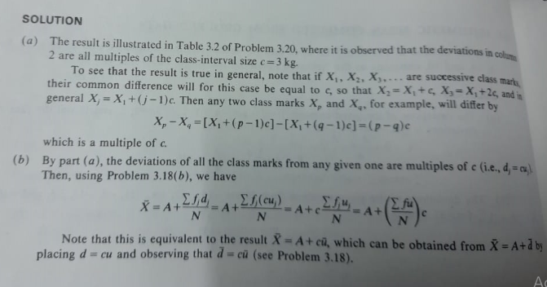

Example 3.3.22 – Codable

Example 3.3.23 – Codable

Example 3.3.24 – Codable

Example 3.3.25 – Codable

Example 3.3.26 – Codable

Example 3.3.27 – Codable

Example 3.3.28 – Codable

Example 3.3.29 – Codable

Example 3.3.30 – Codable

Example 3.3.31 – Codable

Example 3.3.32 –Non- Codable (Reason: Theoretical example with the purpose of proving a concept and variable expression as final solution)

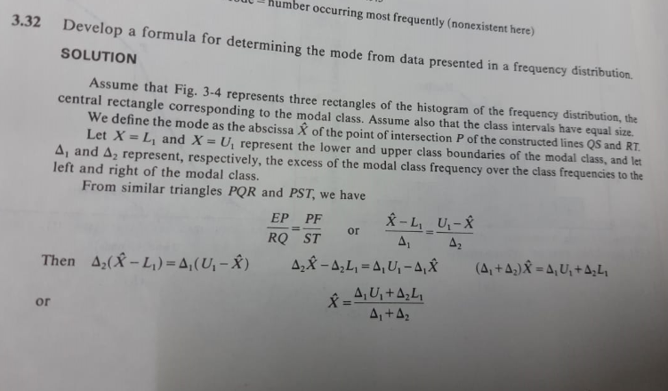

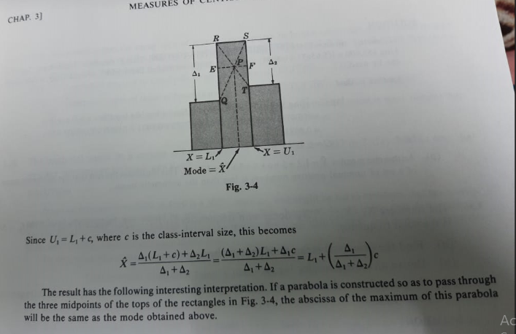

Example 3.3.33 – Codable

Example 3.3.34 – Codable

Example 3.3.35 – Codable

Example 3.3.36 –Non- Codable (Reason: Theoretical example with the purpose of proving a concept and variable expression as final solution)

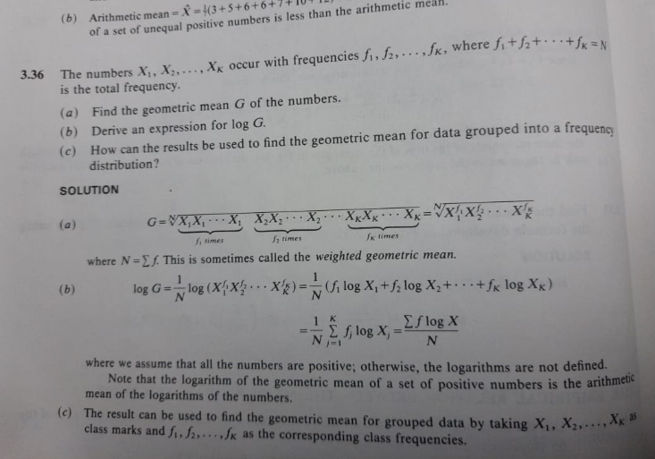

Example 3.3.37 – Codable

Example 3.3.38 – Codable

Example 3.3.39 – Codable

Example 3.3.40 – Codable

Example 3.3.41 – Codable

Example 3.3.42 – Codable

Example 3.3.43 –Non- Codable (Reason: Theoretical example with the purpose of proving a concept and variable expression as final solution)

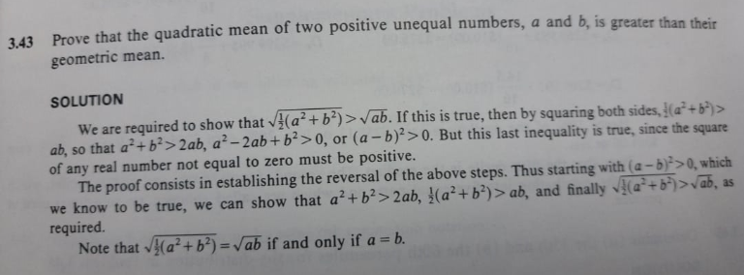

Example 3.3.44 – Codable

Example 3.3.45 – Codable

Example 3.3.46 – Codable

**Chapter 4: The Standard Deviation And Other Measures Of Dispersion**

Example 4.1 – Codable

Example 4.2 – Codable

Example 4. 4.1 – Codable

Example 4. 4.2 – Codable

Example 4. 4.3 – Codable

Example 4. 4.4 – Codable

Example 4. 4.5 – Codable

Example 4. 4.6 – Codable

Example 4. 4.7 – Codable

Example 4. 4.8 – Codable

Example 4. 4.9 – Codable

Example 4. 4.10 – Codable

Example 4. 4.11 – Codable

Example 4. 4.12 – Codable

Example 4. 4.13 –Non- Codable

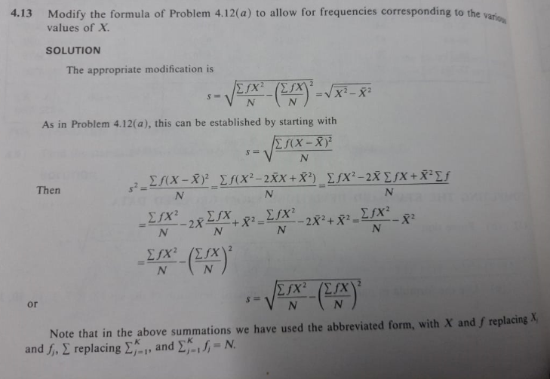

Example 4. 4.14 – Codable

Example 4. 4.15 – Non-Codable (Reason: Theoretical example with the purpose of proving a concept and variable expression as final solution)

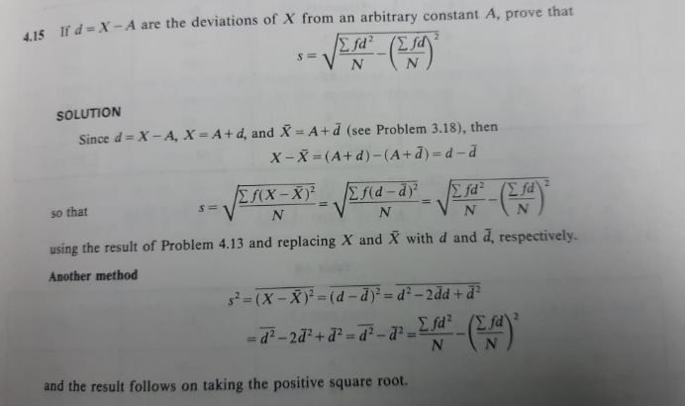

Example 4. 4.16 –Non- Codable (Reason: Theoretical example with the purpose of proving a concept and variable expression as final solution)

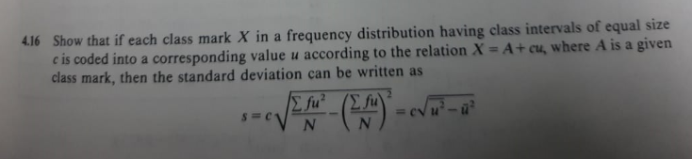

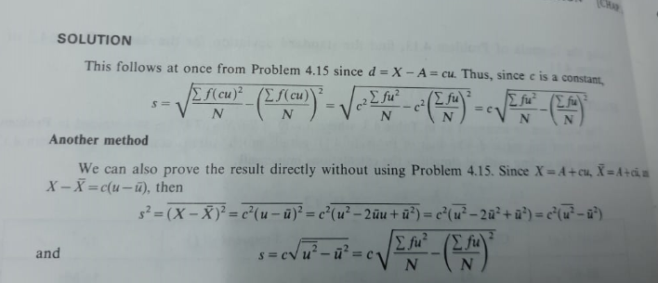

Example 4. 4.17 – Codable

Example 4. 4.18 – Codable

Example 4. 4.19 – Codable

Example 4. 4.20 – Codable

Example 4. 4.21 – Codable

Example 4. 4.22 – Codable

Example 4. 4.23 – Codable

Example 4. 4.24 – Codable

Example 4. 4.25 – Codable

Example 4. 4.26 – Codable

Example 4. 4.27 –Non- Codable (Reason: Theoretical example with the purpose of proving a concept)

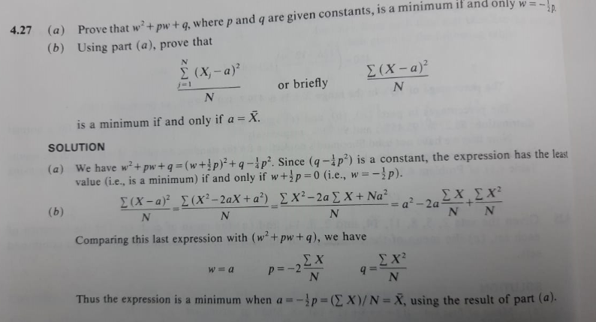

Example 4. 4.28 – Codable

Example 4. 4.29 – Codable

Example 4. 4.30 – Codable

Example 4. 4.31 – Codable

Example 4. 4.32 – Codable

**Chapter 5: Moments, Skewness And Kurtosis**

Example 5. 5.1 – Codable

Example 5. 5.2 – Codable

Example 5. 5.3 – Codable

Example 5. 5.4 – Codable

Example 5. 5.5 –Non- Codable (Reason: Theoretical example with the purpose of proving a concept and variable expression as final solution)

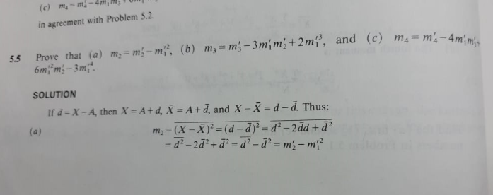

Example 5. 5.6 – Codable

Example 5. 5.7 – Codable

Example 5. 5.8 – Codable

Example 5. 5.9 – Codable

Example 5. 5.10 – Codable

Example 5. 5.11 – Codable

Example 5. 5.12 – Codable

Example 5. 5.13 – Codable

Example 5. 5.14 – Codable

**Chapter 6: Elementary Probability Theory**

Example 6.1 – Codable

Example 6.2 – Codable

Example 6.3 – Codable

Example 6.4 – Codable

Example 6.5– Codable

Example 6.6 – Codable

Example 6.7 – Codable

Example 6.8 – Codable

Example 6.9 – Codable

Example 6.10 – Codable

Example 6.11 –Non- Codable (Reason: Theoretical example with the purpose of proving a concept and variable expression as final solution)

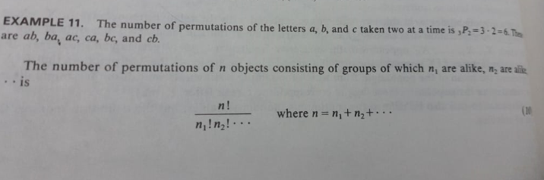

Example 6.12 – Codable

Example 6.13 – Codable

Example 6.6.1 – Codable

Example 6.6.2 – Non-Codable (Reason: Theoretical example with a variable expression as final solution)

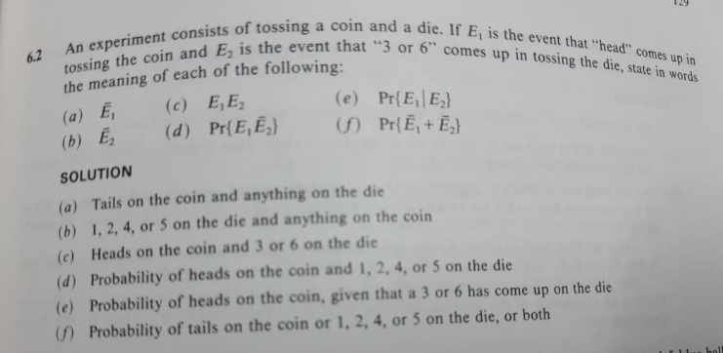

Example 6.6.3 – Codable

Example 6.6.4 – Codable

Example 6.6.5 – Codable

Example 6.6.6 – Codable

Example 6.6.7 – Codable

Example 6.6.8 – Codable

Example 6.6.9 – Codable

Example 6.6.10 – Codable

Example 6.6.11 – Codable

Example 6.6.12 – Codable

Example 6.6.13 – Codable

Example 6.6.14 – Codable

Example 6.6.15 – Codable

Example 6.6.16 – Codable

Example 6.6.17 – Codable

Example 6.6.18– Codable

Example 6.6.19 – Codable

Example 6.6.20 – Codable

Example 6.6.21 – Codable

Example 6.6.22 – Codable

Example 6.6.23 – Codable

Example 6.6.24 – Codable

Example 6.6.25 – Codable

Example 6.6.26 – Codable

Example 6.6.27 – Codable

Example 6.6.28 – Codable

Example 6.6.29 – Codable

Example 6.6.30 – Codable

Example 6.6.31 – Codable

Example 6.6.32 – Codable

Example 6.6.33 – Codable

Example 6.6.34 – Codable

Example 6.6.35 – Codable

Example 6.6.36 – Codable

Example 6.6.37 – Codable

Example 6.6.38 –Non- Codable (Reason: Theoretical example with the purpose of proving a concept )

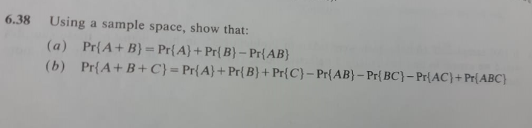

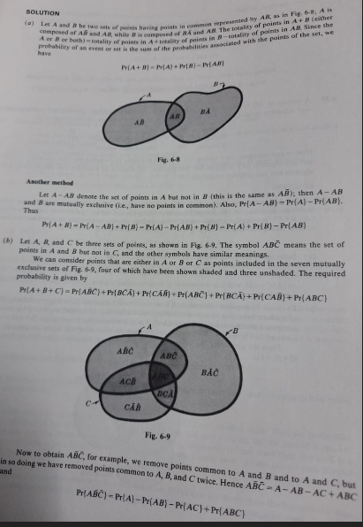

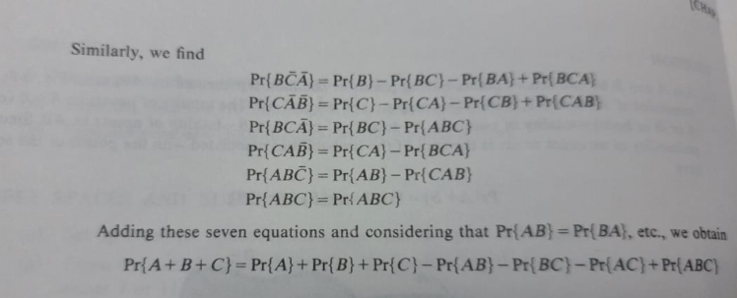

Example 6.6.39 – Codable

**Chapter 7: The Binomial, Normal, and Poisson Distributions**

Example 7.1 – Codable

Example 7.2 – Codable

Example 7.3 –Non- Codable (Reason: Theoretical example with the purpose of proving a concept and gives a variable expression as final solution)

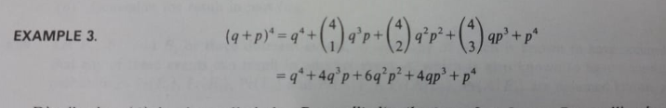

Example 7.4 – Codable

Example 7.5 – Codable

Example 7.7.1 – Codable

Example 7.7.2 – Codable

Example 7.7.3 – Codable

Example 7.7.4 – Non-Codable (Reason: Theoretical example with the purpose of proving a concept and gives a variable expression as final solution)

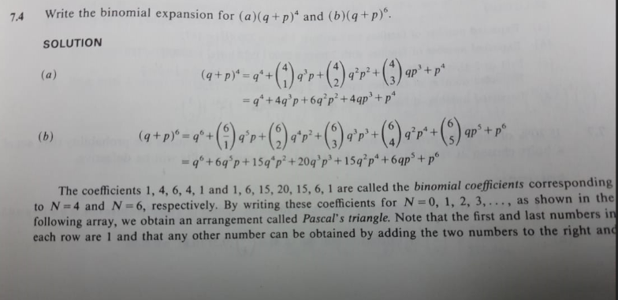

Example 7.7.5 – Codable

Example 7.7.6 – Codable

Example 7.7.7 – Codable

Example 7.7.8 – Codable

Example 7.7.9 – Codable

Example 7.7.10 –Non- Codable (Reason: Theoretical example with the purpose of proving a concept )

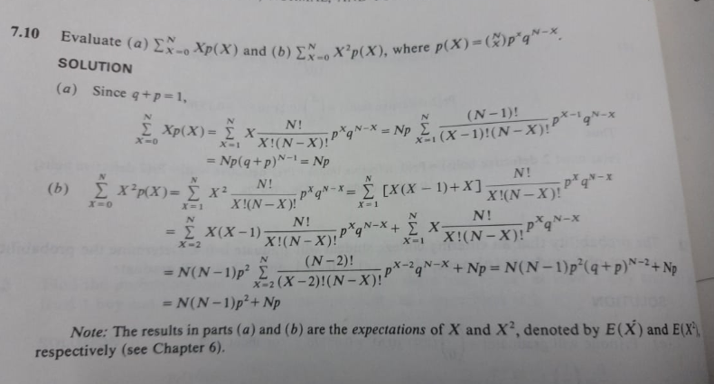

Example 7.7.11 – Non-Codable (Reason: Theoretical example with the purpose of proving a concept)

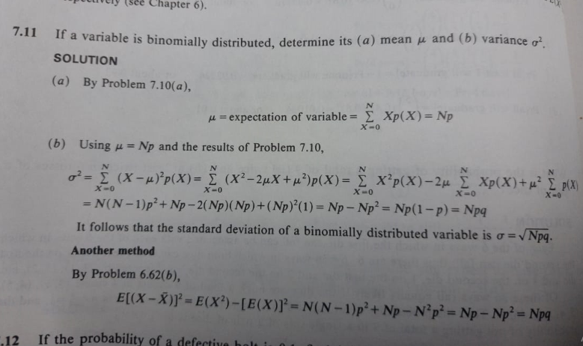

Example 7.7.12 – Codable

Example 7.7.13 – Codable

Example 7.7.14 – Codable

Example 7.7.15 – Codable

Example 7.7.16 – Codable

Example 7.7.17 – Codable

Example 7.7.18 – Codable

Example 7.7.19 – Codable

Example 7.7.20 – Codable

Example 7.7.21 – Codable

Example 7.7.22 – Codable

Example 7.7.23 – Codable

Example 7.7.24 – Codable

Example 7.7.25 – Codable

Example 7.7.26 – Codable

Example 7.7.27 – Codable

Example 7.7.28 – Codable

Example 7.7.29 – Codable

Example 7.7.30 – Codable

Example 7.7.31 – Codable

Example 7.7.32 – Codable

Example 7.7.33 – Codable

Example 7.7.34 – Codable

**Chapter 8: Elementary Sampling Theory**

Example 8.8.1 – Codable

Example 8.8.2 – Codable

Example 8.8.3 – Codable

Example 8.8.4 – Codable

Example 8.8.5 – Codable

Example 8.8.6 – Codable

Example 8.8.7 – Codable

Example 8.8.8 – Codable

Example 8.8.9 – Codable

Example 8.8.10 – Codable

Example 8.8.11 – Codable

Example 8.8.12 – Codable

Example 8.8.13 – Codable

Example 8.8.14 – Codable

Example 8.8.15 – Codable

Example 8.8.16 – Codable

Example 8.8.17 – Codable

Example 8.8.18 – Codable

Example 8.8.19 – Codable

Example 8.8.20 – Codable

**Chapter 9: Statistical Estimation Theory**

Example 9.9.1 –Non- Codable (Reason: Theoretical example with the purpose of proving a concept )

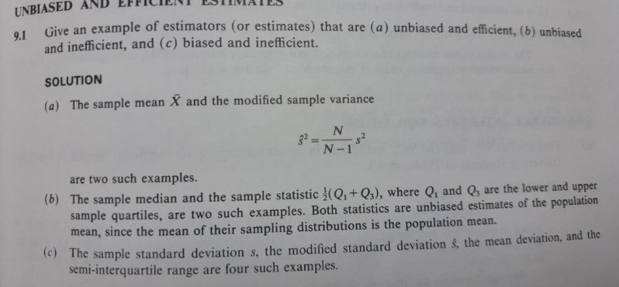

Example 9.9.2 – Codable

Example 9.9.3 – Codable

Example 9.9.4 – Codable

Example 9.9.5 – Codable

Example 9.9.6 – Codable

Example 9.9.7 – Codable

Example 9.9.8 – Codable

Example 9.9.9 – Codable

Example 9.9.10 – Codable

Example 9.9.11 – Codable

Example 9.9.12 – Codable

Example 9.9.13 – Codable

Example 9.9.14 – Codable

Example 9.9.15 – Codable

Example 9.9.16 – Codable

Example 9.9.17 – Codable

Example 9.9.18 – Codable

Example 9.9.19 – Codable

Example 9.9.20 – Codable

**Chapter 10: Statistical Decision Theory**

Example 10.10.1 – Codable

Example 10.10.2 – Codable

Example 10.10.3 – Codable

Example 10.10.4 –Non- Codable (Reason: Theoretical example with the purpose of proving a concept)

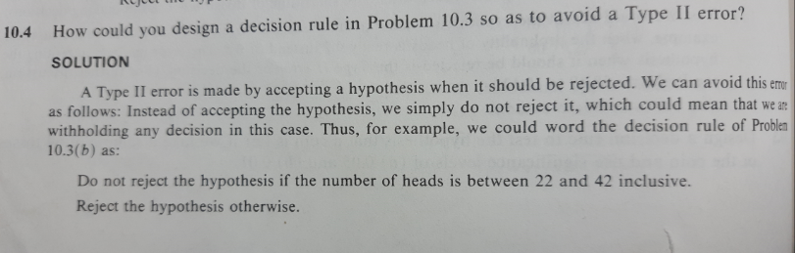

Example 10.10.5 – Codable

Example 10.10.6 – Codable

Example 10.10.7 – Codable

Example 10.10.8 – Codable

Example 10.10.9 – Codable

Example 10.10.10 – Codable

Example 10.10.11 – Codable

Example 10.10.12 – Codable

Example 10.10.13 – Codable

Example 10.10.14 – Codable

Example 10.10.15 – Codable

Example 10.10.16 – Codable

Example 10.10.17 – Codable

Example 10.10.18 – Codable

Example 10.10.19 – Codable

Example 10.10.20 – Codable

Example 10.10.21 – Codable

Example 10.10.22 – Codable

Example 10.10.23 – Codable

Example 10.10.24 – Codable

Example 10.10.25 – Codable

Example 10.10.26 – Codable

Example 10.10.27 – Codable

Example 10.10.28 – Codable

**Chapter 11: Small Sampling Theory**

Example 11.11.1 – Codable

Example 11.11.2 – Codable

Example 11.11.3 – Codable

Example 11.11.4 – Codable

Example 11.11.5 – Codable

Example 11.11.6 – Codable

Example 11.11.7 – Codable

Example 11.11.8 – Codable

Example 11.11.9 – Codable

Example 11.11.10 – Codable

Example 11.11.11 – Codable

Example 11.11.12 – Codable

Example 11.11.13 – Codable

Example 11.11.14 – Codable

Example 11.11.15 – Codable

Example 11.11.16 –Non- Codable (Reason: Theoretical example with the purpose of proving a concept)

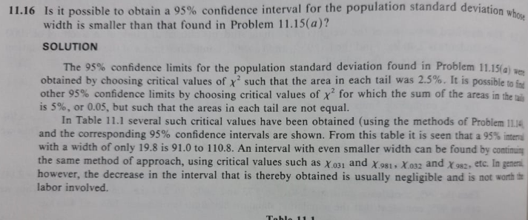

Example 11.11.17 – Codable

Example 11.11.18 – Codable

Example 11.11.19 – Codable

**Chapter 12: The Chi-Square Test**

Example 12.12.1 – Codable

Example 12.12.2 – Codable

Example 12.12.3 – Codable

Example 12.12.4 – Codable

Example 12.12.5 – Codable

Example 12.12.6 – Codable

Example 12.12.7 – Codable

Example 12.12.8 – Codable

Example 12.12.9 – Codable

Example 12.12.10 – Non-Codable (Reason: Theoretical example with the purpose of proving a concept and gives a variable expression as final solution)

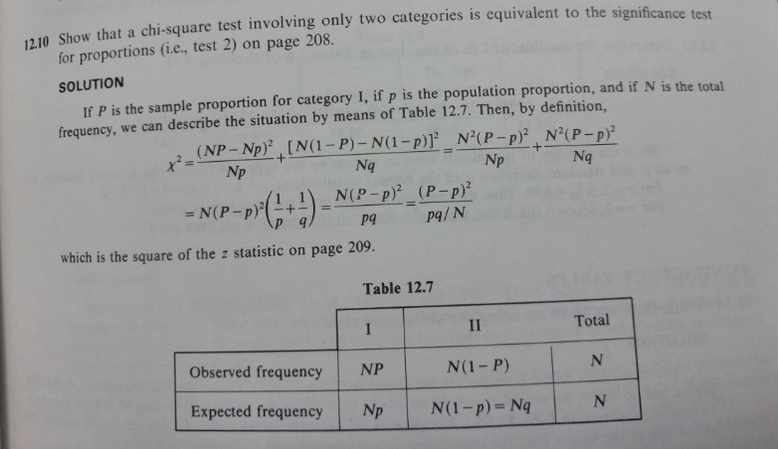

Example 12.12.11 – Codable

Example 12.12.12 – Codable

Example 12.12.13 – Codable

Example 12.12.14 – Codable

Example 12.12.15 – Codable

Example 12.12.16 – Codable

Example 12.12.17 – Codable

Example 12.12.18 – Non-Codable (Reason: Theoretical example with the purpose of proving a concept)

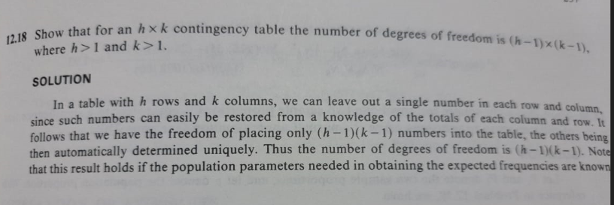

Example 12.12.19 – Codable

Example 12.12.20 – Non-Codable (Reason: Theoretical example with the purpose of proving a concept and gives a variable expression as final solution)

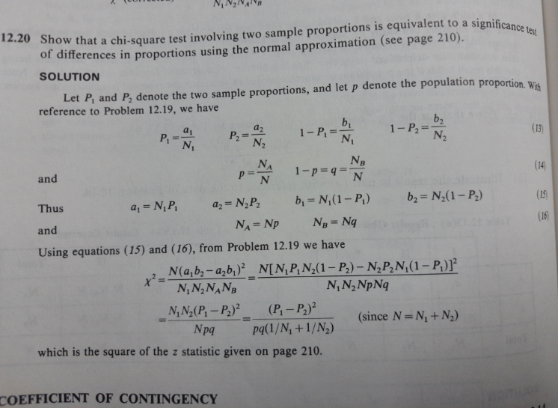

Example 12.12.21 – Codable

Example 12.12.22 – Codable

Example 12.12.23 – Codable

Example 12.12.24 – Non-Codable (Reason: Theoretical example with the purpose of proving a concept )

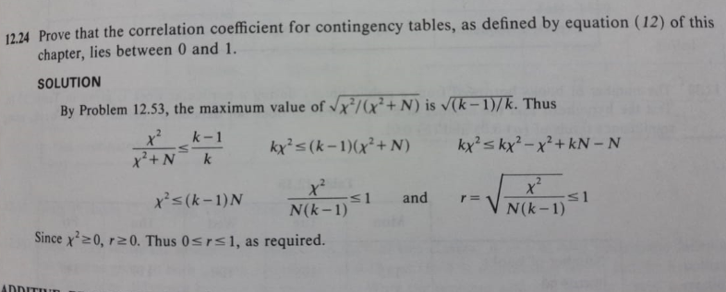

Example 12.12.25 – Codable

**Chapter 13: Curve Fitting and the Method of Least Square**

Example 13.13.1 – Codable

Example 13.13.2 – Codable

Example 13.13.3 – Codable

Example 13.13.4 –Non- Codable (Reason: Theoretical example with the purpose of proving a concept and gives a variable expression as final solution)

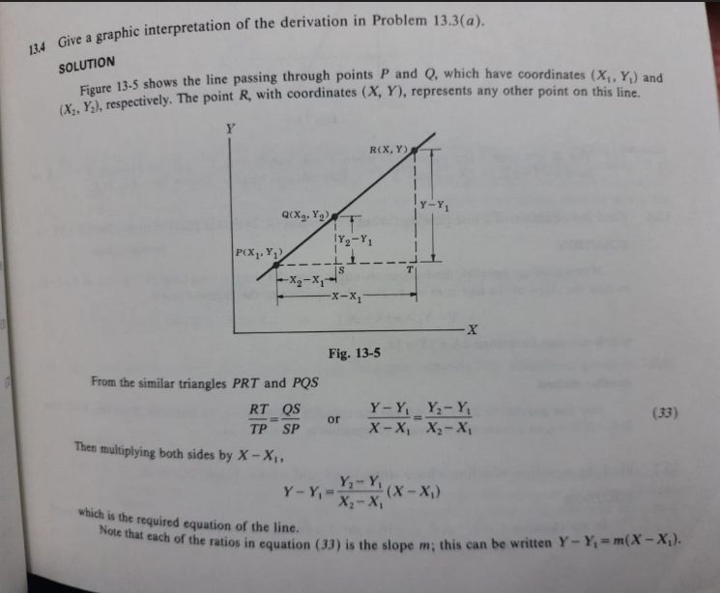

Example 13.13.5 – Codable

Example 13.13.6 –Non- Codable (Reason: resulting in a variable expression as the final solution)

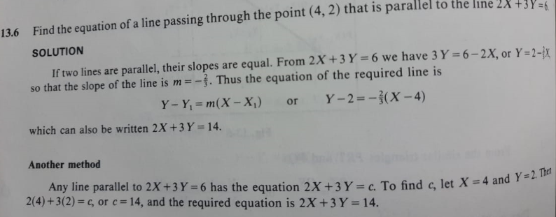

Example 13.13.7 – Codable

Example 13.13.8 – Codable

Example 13.13.9 – Codable

Example 13.13.10 – Codable

Example 13.13.11 – Codable

Example 13.13.12 – Codable

Example 13.13.13 –Codable

Example 13.13.14 – Non-Codable (Reason: Theoretical example with the purpose of proving a concept)

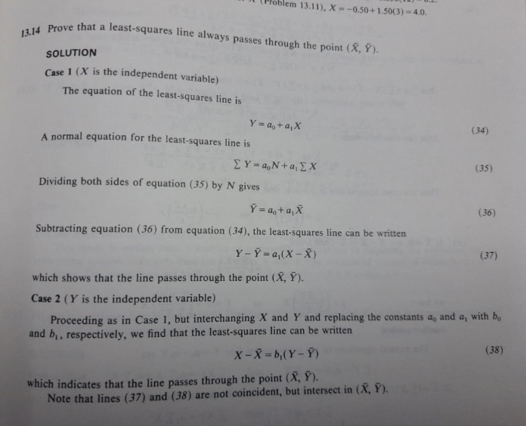

Example 13.13.15 – Non-Codable Example 1.2 – Non-Codable (Reason: Theoretical example with the purpose of proving a concept)

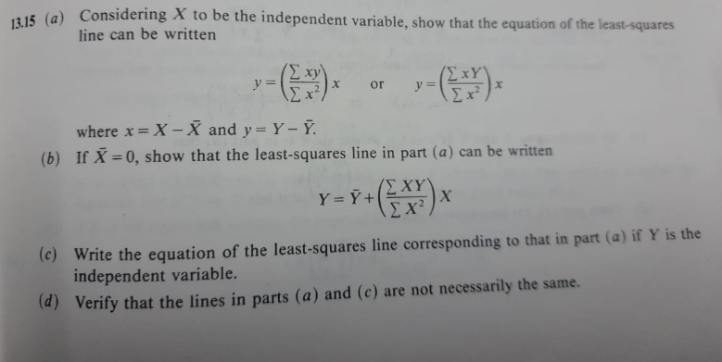

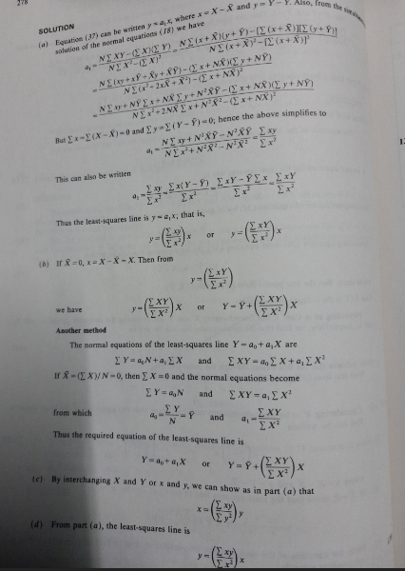

Example 13.13.16 – Non-Codable Example 1.2 – Non-Codable (Reason: Theoretical example with the purpose of proving a concept)

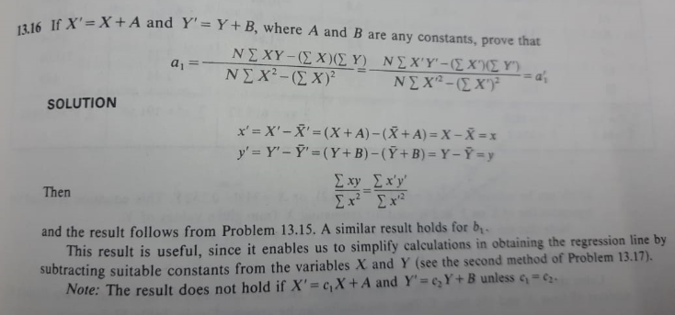

Example 13.13.17 – Codable

Example 13.13.18 – Codable

Example 13.13.19 – Codable

Example 13.13.20 – Codable

Example 13.13.21 – Codable

Example 13.13.22 – Codable

Example 13.13.23 – Codable

**Chapter 14: Correlation Theory**

Example 14.14.1 – Codable

Example 14.14.2 – Codable

Example 14.14.3 –Non- Codable (Reason: Theoretical example with the purpose of proving a concept)

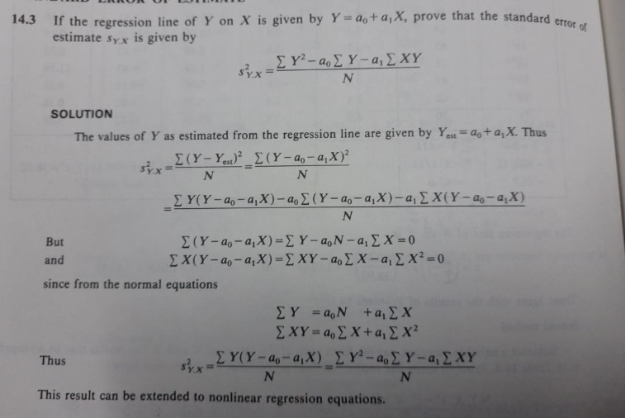

Example 14.14.4 – Non-Codable (Reason: Theoretical example with the purpose of proving a concept)

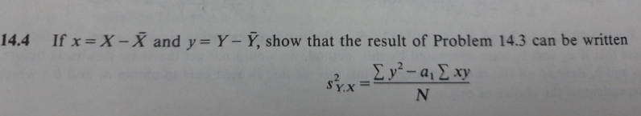

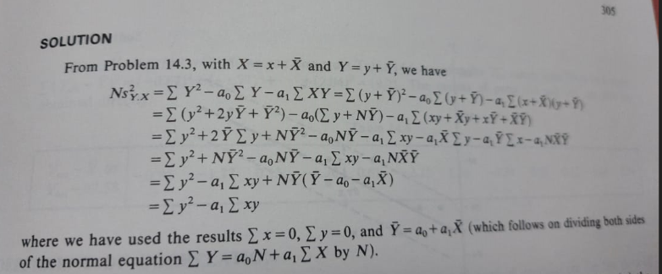

Example 14.14.5 – Codable

Example 14.14.6 – Codable

Example 14.14.7 – Non-Codable (Reason: Theoretical example with the purpose of proving a concept)

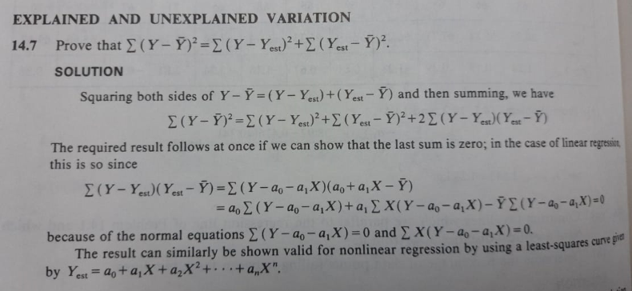

Example 14.14.8 – Codable

Example 14.14.9 – Codable

Example 14.14.10 –Non- Codable (Reason: Theoretical example with the purpose of proving a concept)

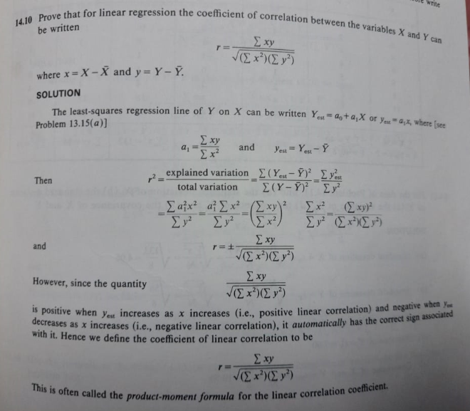

Example 14.14.11 – Codable

Example 14.14.12 – Codable

Example 14.14.13 – Codable

Example 14.14.14 – Codable

Example 14.14.15 – Non-Codable (Reason: Theoretical example with the purpose of proving a concept)

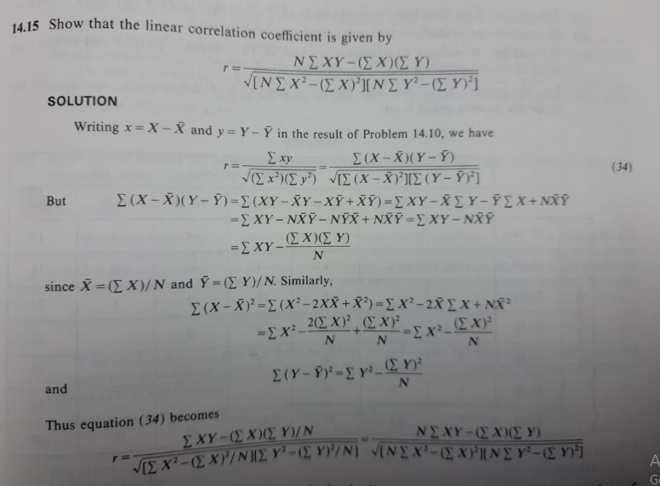

Example 14.14.16 – Codable

Example 14.14.17 – Codable

Example 14.14.18 –Non- Codable (Reason: Theoretical example with the purpose of proving a concept)

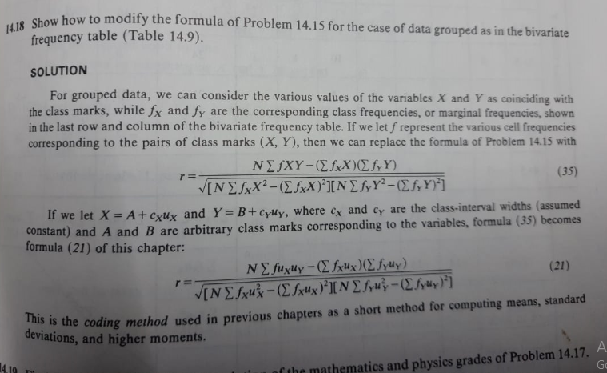

Example 14.14.19 – Codable

Example 14.14.20 – Codable

Example 14.14.21 – Non-Codable (Reason: Theoretical example with the purpose of proving a concept)

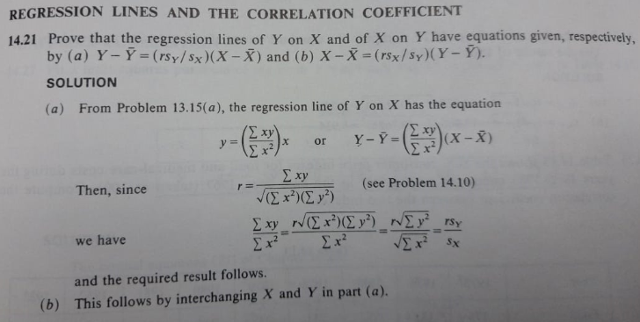

Example 14.14.22 – Non-Codable (Reason: Theoretical example with the purpose of proving a concept)

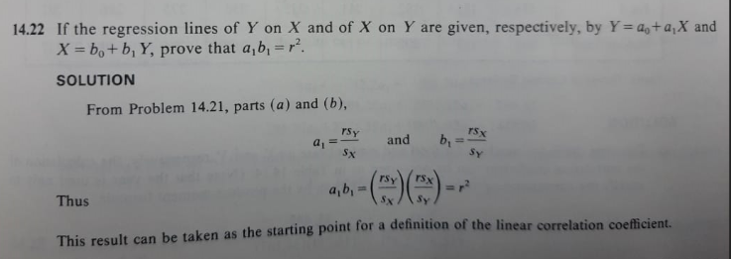

Example 14.14.23 – Codable

Example 14.14.24 – Codable

Example 14.14.25 – Codable

Example 14.14.26 – Codable

Example 14.14.27 – Codable

Example 14.14.28 – Codable

Example 14.14.29 – Codable

Example 14.14.30 – Codable

Example 14.14.31 – Codable

Example 14.14.32 – Codable

Example 14.14.33 – Codable

Example 14.14.34 – Codable

Example 14.14.35 – Codable

Example 14.14.36 – Codable

Example 14.14.37 – Codable

Example 14.14.38 – Codable

Example 14.14.39 – Codable

**Chapter 15: Multiple and Partial Correlation**

Example 15.15.1 –Non- Codable (Reason: Theoretical example with the purpose of proving a concept)

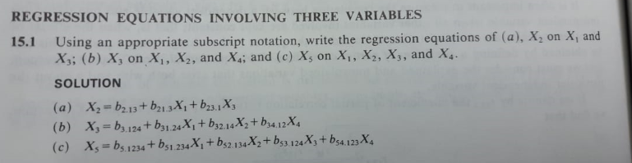

Example 15.15.2 – Non-Codable (Reason: Theoretical example with the purpose of proving a concept)

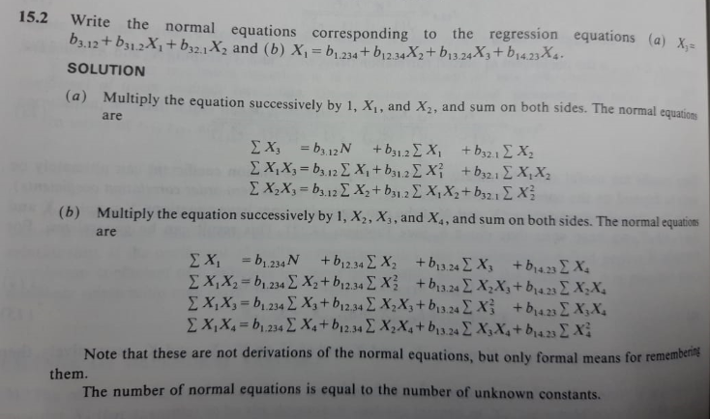

Example 15.15.3 – Codable

Example 15.15.4 – Codable

Example 15.15.5 – Codable

Example 15.15.6 – Codable

Example 15.15.7 – Codable

Example 15.15.8 – Non-Codable (Reason: Theoretical example with the purpose of proving a concept)

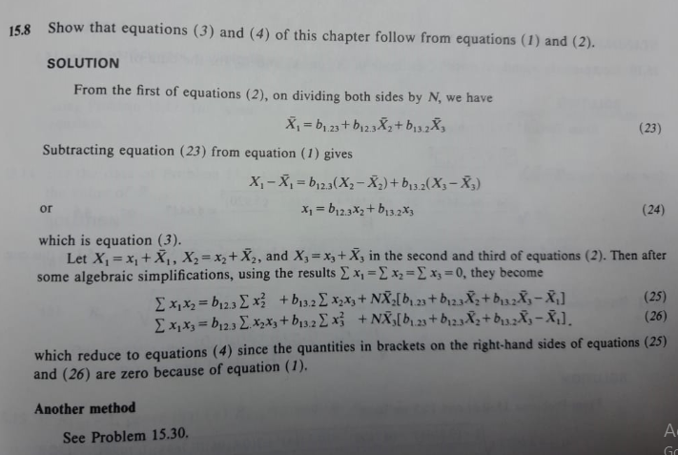

Example 15.15.9 – Non-Codable (Reason: Theoretical example with the purpose of proving a concept)

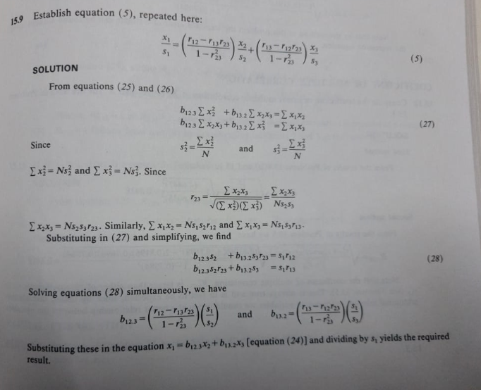

Example 15.15.10 – Codable

Example 15.15.11 – Codable

Example 15.15.12 – Codable

Example 15.15.13 – Codable

Example 15.15.14 – Codable

Example 15.15.15 – Non-Codable (Reason: Theoretical example with the purpose of proving a concept)

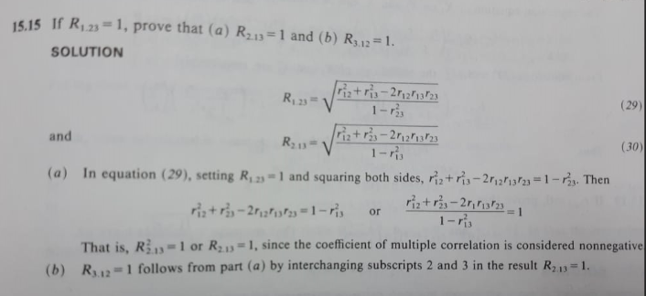

Example 15.15.16 – Non-Codable (Reason: Theoretical example with the purpose of proving a concept)

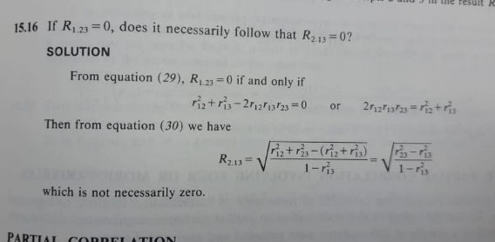

Example 15.15.17 – Codable

Example 15.15.18 – Non-Codable (Reason: Theoretical example with the purpose of proving a concept)

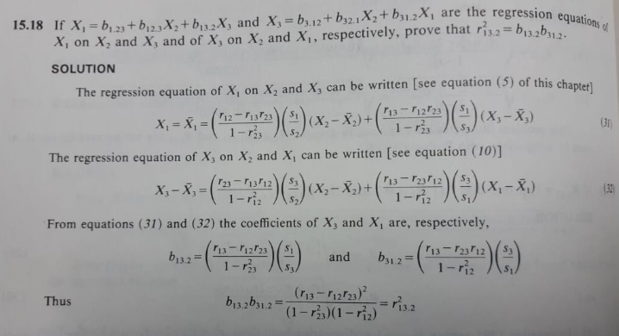

Example 15.15.19 –Non- Codable (Reason: Theoretical example with the purpose of proving a concept)

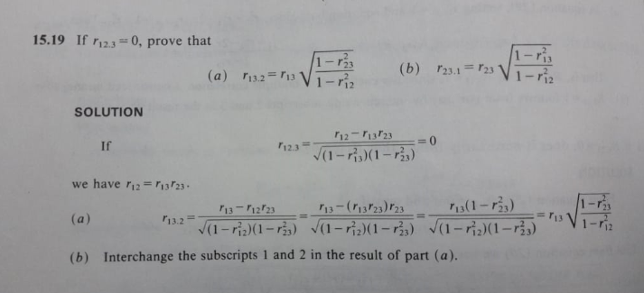

Example 15.15.20 – Codable

Example 15.15.21 – Codable

Example 15.15.22 – Codable

Example 15.15.23 –Non- Codable (Reason: Theoretical example with the purpose of proving a concept)

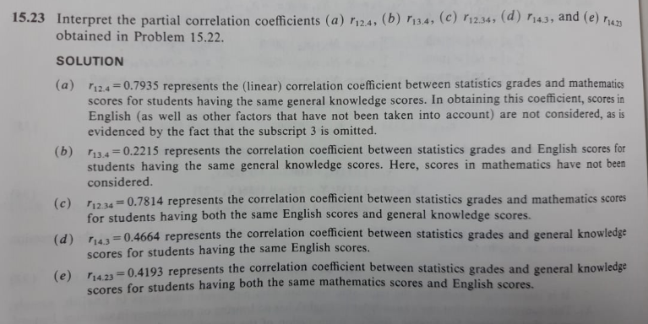

Example 15.15.24 – Codable

Example 15.15.25 – Codable

**Chapter 16: Analysis Of Variance**

Example 16.16.1 –Non- Codable (Reason: Theoretical example with the purpose of proving a concept)

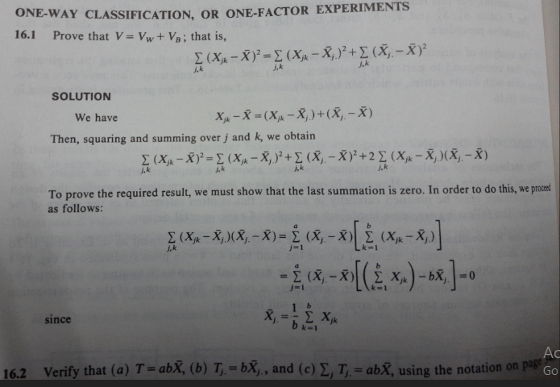

Example 16.16.2 – Non-Codable (Reason: Theoretical example with the purpose of proving a concept)

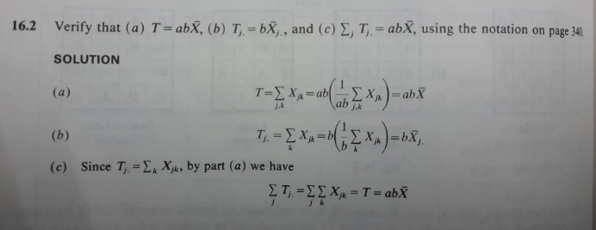

Example 16.16.3 – Non-Codable (Reason: Theoretical example with the purpose of proving a concept)

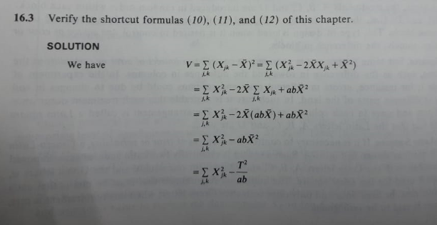

Example 16.16.4 – Codable

Example 16.16.5 – Codable

Example 16.16.6 – Codable

Example 16.16.7 – Codable

Example 16.16.8 – Codable

Example 16.16.9 – Codable

Example 16.16.10 – Codable

Example 16.16.11 – Codable

Example 16.16.12 – Codable

Example 16.16.13 – Codable

Example 16.16.14 – Codable

Example 16.16.15 – Codable

Example 16.16.16 –Non- Codable (Reason: Theoretical example with the purpose of proving a concept)

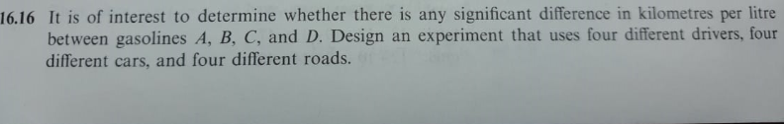

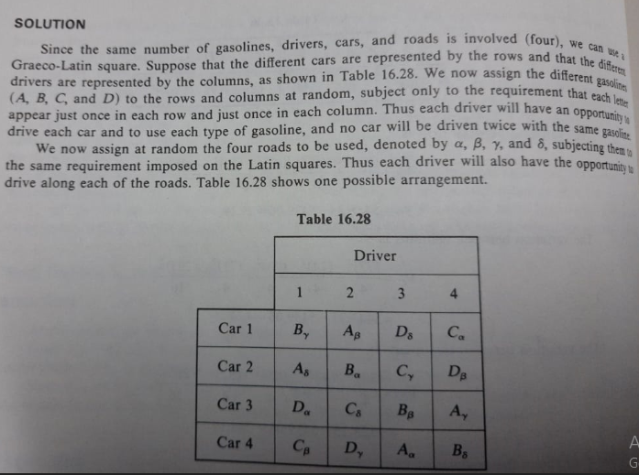

Example 16.16.17 – Codable

Example 16.16.18 –Non- Codable (Reason: Theoretical example with the purpose of proving a concept)

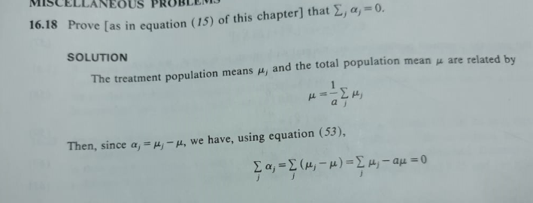

Example 16.16.19 –Non- Codable (Reason: Theoretical example with the purpose of proving a concept)

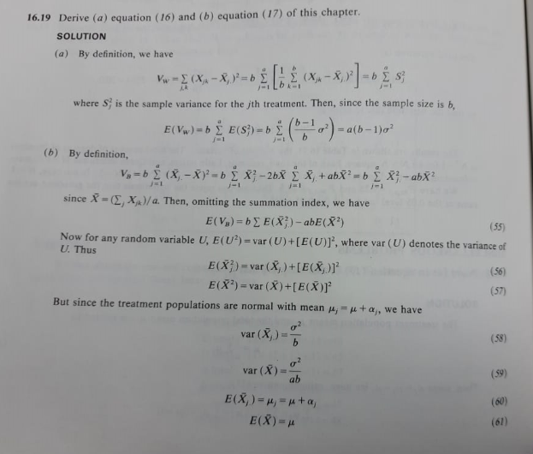

Example 16.16.20 –Non- Codable (Reason: Theoretical example with the purpose of proving a concept)

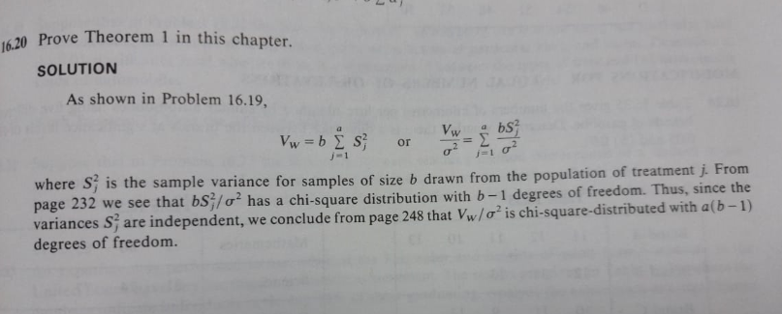

**Chapter 17: Nonparametric Tests**

Example 17.17.1 – Codable

Example 17.17.2 – Codable

Example 17.17.3 – Codable

Example 17.17.4 – Codable

Example 17.17.5 – Codable

Example 17.17.6 – Codable

Example 17.17.7 – Codable

Example 17.17.8 – Codable

Example 17.17.9 – Codable

Example 17.17.10 – Codable

Example 17.17.11 – Codable

Example 17.17.12 – Non-Codable (Reason: Theoretical example with the purpose of proving a concept)

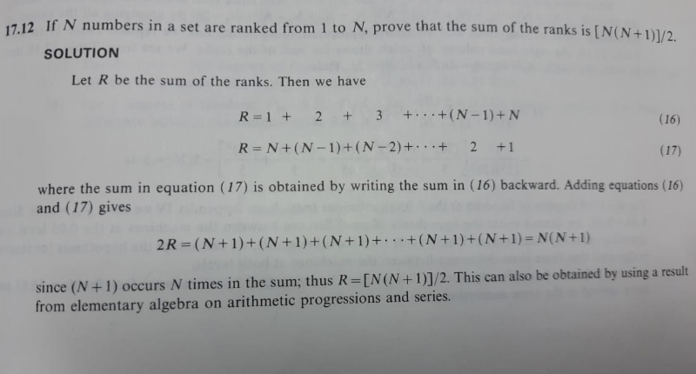

Example 17.17.13 – Non-Codable (Reason: Theoretical example with the purpose of proving a concept)

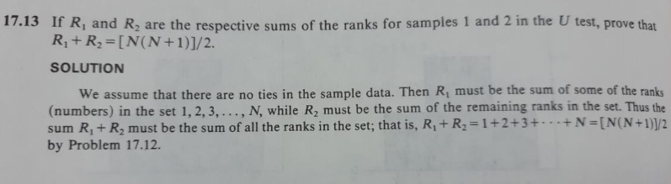

Example 17.17.14 – Codable

Example 17.17.15 – Codable

Example 17.17.16 – Codable

Example 17.17.17 – Codable

Example 17.17.18 – Codable

Example 17.17.19 – Codable

Example 17.17.20 – Codable

Example 17.17.21 – Codable

Example 17.17.22 – Codable

Example 17.17.23 – Codable

Example 17.17.24 – Codable

**Chapter 18: Analysis Of Time Series**

Example 18.1 – Codable

Example 18.2 – Codable

Example 18.18.1 – Non-Codable (Reason: Theoretical example with the purpose of proving a concept)

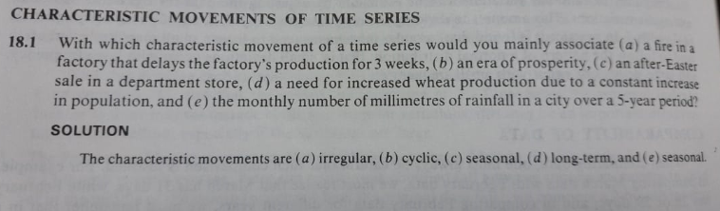

Example 18.18.2 – Codable

Example 18.18.3 – Codable

Example 18.18.4 – Codable

Example 18.18.5 – Codable

Example 18.18.6 – Codable

Example 18.18.7 – Codable

Example 18.18.8 – Codable

Example 18.18.9 – Codable

Example 18.18.10 – Codable

Example 18.18.11 – Codable

Example 18.18.12 – Codable

Example 18.18.13 – Codable

Example 18.18.14 – Codable

Example 18.18.15 – Codable

Example 18.18.16 – Codable

Example 18.18.17 – Codable

Example 18.18.18 – Codable

Example 18.18.19 – Codable

Example 18.18.20 – Codable

Example 18.18.21 – Codable

**Chapter 19: Index Numbers**

Example 19.1 – Codable

Example 19.2 – Codable

Example 19.3 – Codable

Example 19.4 – Codable

Example 19.5 – Codable

Example 19.19.1 – Codable

Example 19.19.2 – Non-Codable (Reason: Theoretical example with the purpose of proving a concept)

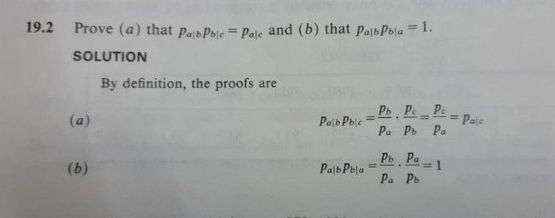

Example 19.19.3 – Codable

Example 19.19.4 – Codable

Example 19.19.5 – Codable

Example 19.19.6 – Codable

Example 19.19.7 – Codable

Example 19.19.8 – Codable

Example 19.19.9 – Codable

Example 19.19.10 – Codable

Example 19.19.11 –Non- Codable (Reason: Theoretical example with the purpose of proving a concept)

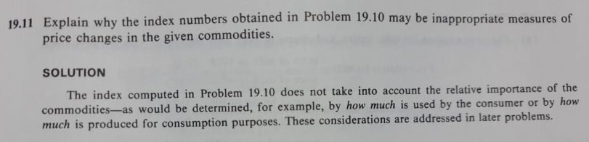

Example 19.19.12 – Codable

Example 19.19.13 – Codable

Example 19.19.14 – Codable

Example 19.19.15 – Codable

Example 19.19.16 – Codable

Example 19.19.17 – Codable

Example 19.19.18 – Codable

Example 19.19.19 – Codable

Example 19.19.20 – Codable

Example 19.19.21 – Non-Codable (Reason: Theoretical example with the purpose of proving a concept)

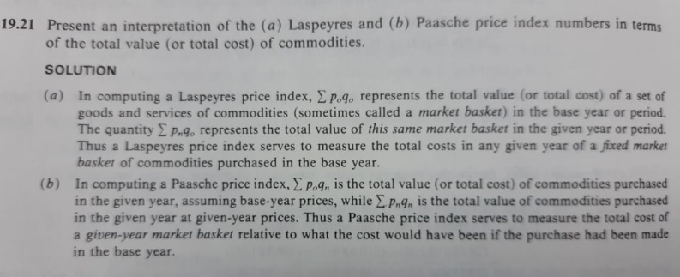

Example 19.19.22 – Non-Codable (Reason: Theoretical example with the purpose of proving a concept)

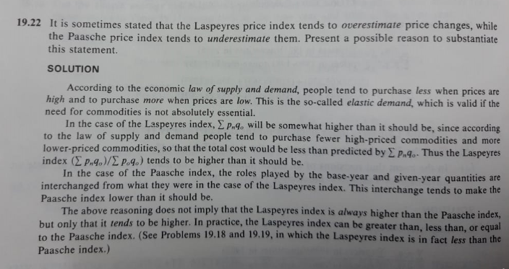

Example 19.19.23 – Non-Codable (Reason: Theoretical example with the purpose of proving a concept)

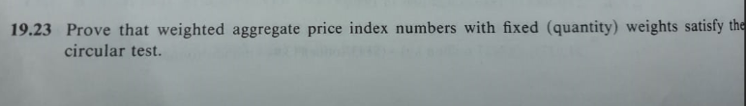

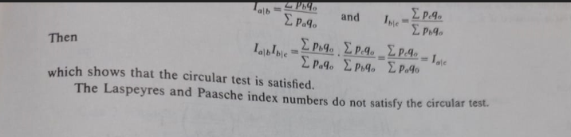

Example 19.19.24 – Non-Codable (Reason: Theoretical example with the purpose of proving a concept)

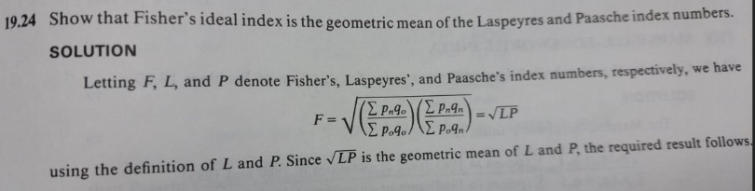

Example 19.19.25 – Non-Codable (Reason: Theoretical example with the purpose of proving a concept)

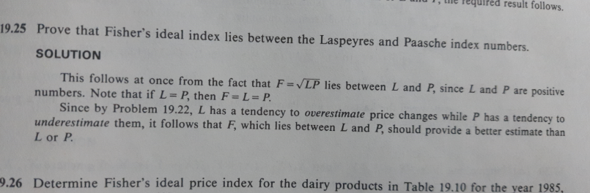

Example 19.19.26 – Codable

Example 19.19.27 – Codable

Example 19.19.28 –Non- Codable (Reason: Theoretical example with the purpose of proving a concept)

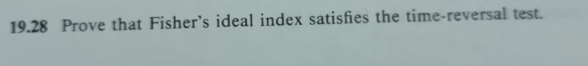

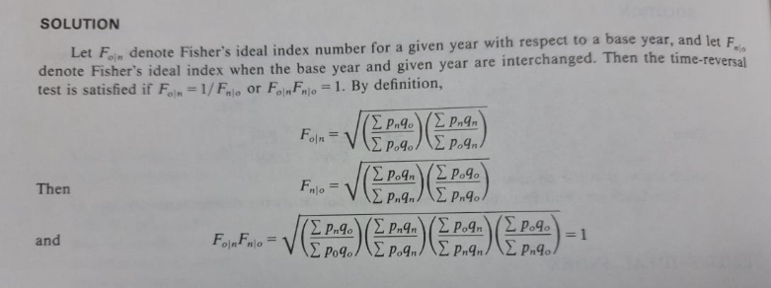

Example 19.19.29 – Codable

Example 19.19.30 – Non-Codable (Reason: Theoretical example with the purpose of proving a concept)

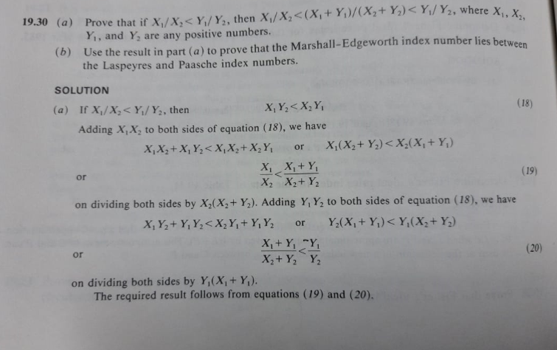

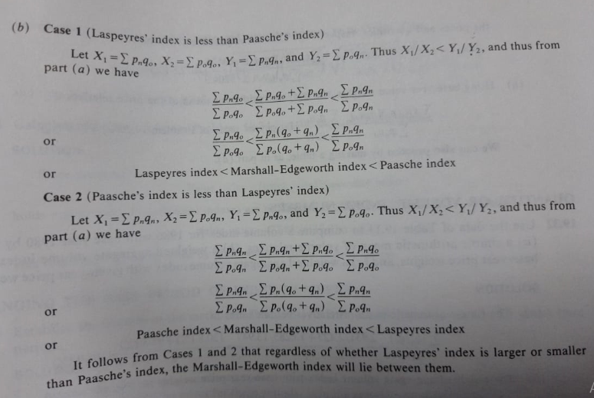

Example 19.19.31 – Codable

Example 19.19.32 – Codable

Example 19.19.33 – Codable

Example 19.19.34 – Non-Codable (Reason: Theoretical example with the purpose of proving a concept)

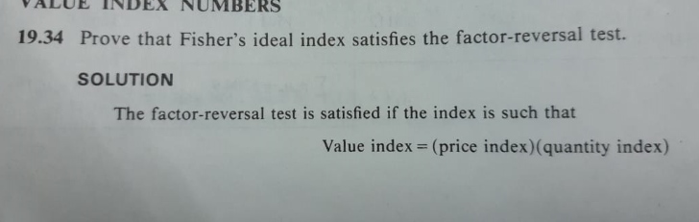

Example 19.19.35 – Codable

Example 19.19.36 –Non- Codable

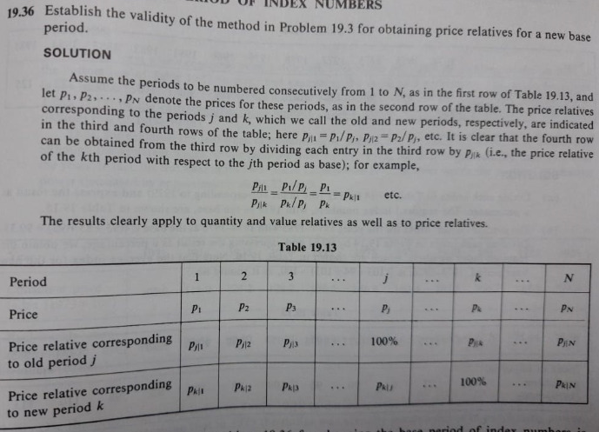

Example 19.19.37 –Non- Codable

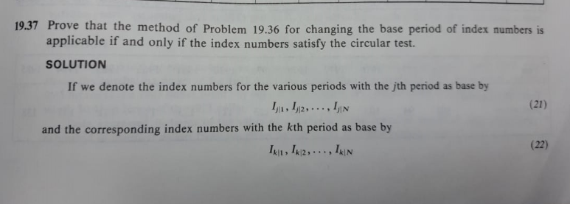

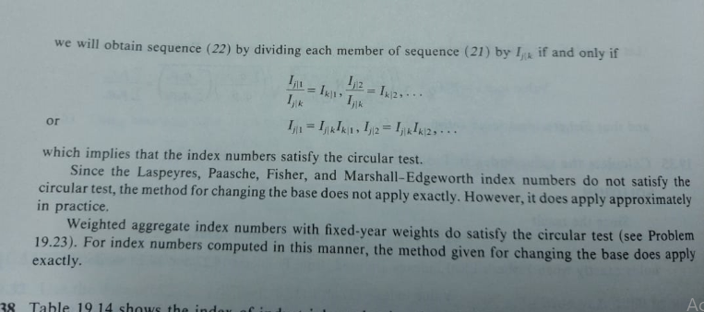

Example 19.19.38 – Codable

Example 19.19.39 – Codable

Example 19.19.40 – Codable